Intermediate Algebra Lecture 7.6: Using Proportions and Rational Methods in Problem Solving

Proportions - one fraction equal to another. (cross multiple a proportion the results equal

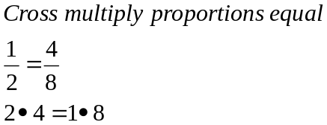

Example
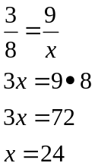

Example
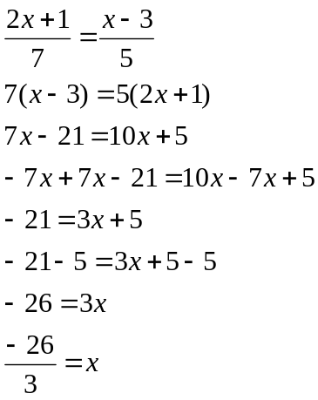

Example
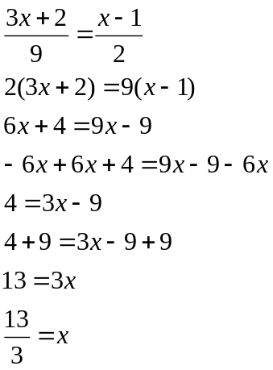

Problem Solving
Group the same units together as a complete fraction, or group the same units as denominators or numerators.

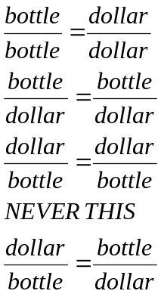

Went to the store and bought 4, 2 litre sodas at $5.16
How much will 7 sodas cost me?

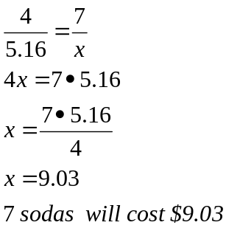

Similar Triangles
Different sizes of triangles, but same shape.
Corresponding sides are proportional.

Example

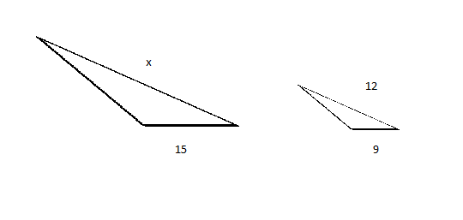
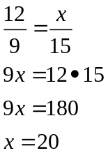

Example
The quotient of a number and 2 minus 1/3
/ b -
Is the quotient of the number and 6
= / b

Quotient means divide
A number means variable in this case b
Is means = sign

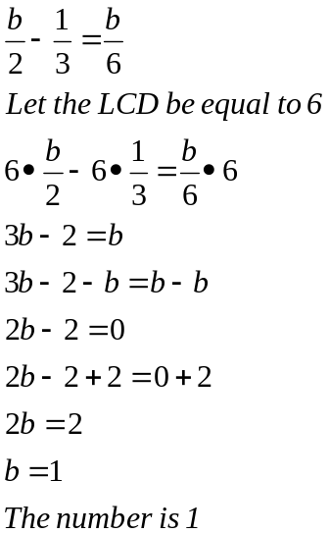

Example
Tim and John have the same job
Tim takes 2 hours for a job.
John takes 3 hours for a job
How long will it take for them to do the job together

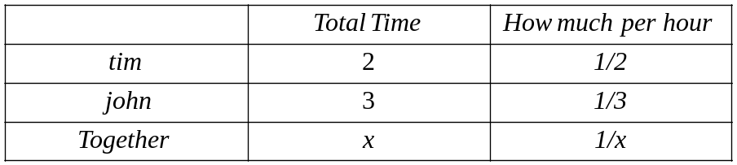

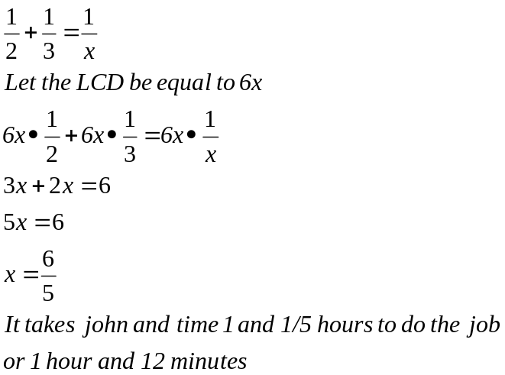

Example
If a car travels 600 miles in the same time
A truck travels 450 miles

If the cars speed is 15mph more than the trucks
What are the speeds?

Hint solve for the thing that is the same.
Formula : Distance = rate * time (d=r*t)

